CURRICULUM VITÆ

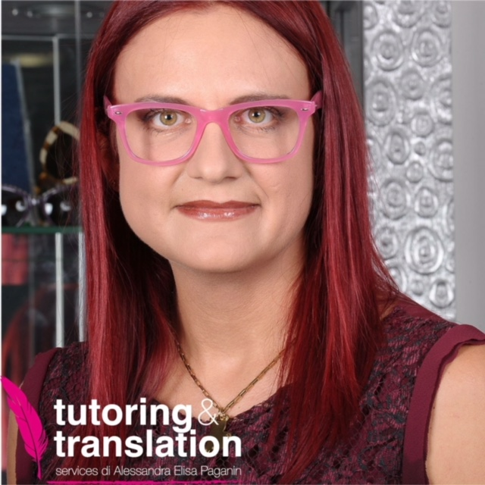

PERSONAL DATA

NAME: Alessandra Elisa
SURNAME: Paganin
PLACE OF BIRTH: Lecco
DATE OF BIRTH: 30/05/1982
DUAL NATIONALITY: French and Italian
AGE: 31
ADDRESS: Via Dante 13, 23825 Esino Lario (LC) ITALY
TELEPHONE/FAX: 0341/860077
MOBILE: 333/3481999
E-MAIL: alepagus@yahoo.it / alepagus@gmail.com
CODICE FISCALE: PGNLSN82E70E507H
P.IVA 03171700135
Tutoring&Translation Services di Alessandra Elisa Paganin

STUDIES AND FORMATIVE EXPERIENCES

- DEGREE IN LANGUAGES AND TECHNIQUES OF INFORMATION AND COMMUNICATION, at the Catholic University of the Sacred Heart of Milan, on March 23rd 2005. Thesis in French literature, title “The inner places of Zola’s Curée”.
Mark: 110/100 WITH HONOURS.

PRINCIPAL SUBJECTS STUDIED:
      - General sector: information theory, social psychology, philosophy of language, general informatics, semiotics, theories and techniques of mass media, anthropology, communication law.
      - Specific sector: oral and written exams of English (I ^{rst}, II ^{nd} and III ^{rd} year), oral and written exams of French (I ^{rst}, II ^{nd} and III ^{rd} year), Italian language, French linguistics, English linguistics, French literature (I ^{rst}, II ^{nd} and III ^{rd} year), English literature (I ^{rst}, II ^{nd} and III ^{rd} year), general linguistics.

- SECONDARY SCHOOL DIPLOMA IN LANGUAGES AT THE “G. BERTACCHI” SCHOOL, Via XI Febbraio, in Lecco. Mark: 80/100.
      - General sector: history and geography, law, philosophy, mathematics, Latin, arts and science.
      - Specific sector: Italian, first foreign language ( 5 years of English = 627 hours), second foreign language ( 5 years of French = 693 hours), third foreign language ( 3 Years of Spanish = 495 hours).

LANGUAGES KNOWLEDGE

FRENCH: oral and written ability: excellent. MOTHERTONGUE
I’ve obtained the French 1^{rst} degree Diploma (DELF) while I was going to the secondary
school. Mark: 19/20

ENGLISH: oral ability excellent. Written ability: excellent. I’ve been living 2 years in the UK, in Malvern- Worcestershire.

SPANISH: oral and written ability: sufficient.

INFORMATICS KNOWLEDGE

I’ve obtained The European Computer Driving Licence (ECDL) on March 20th 2002 at the Catholic University in Milan. I Know thoroughly the majority of softwares used for virtual classes.

OTHER INFORMATION

I spent part of my childhood in France in my grandfather’s house. I’ve learnt the language there.
I've written most of my lessons in the three languages.
References under request and also visible on LinkedIn:
http://www.linkedin.com/profile/view?id=91261512&trk=nav_responsive_tab_profile

WORK EXPERIENCES

- Collaborations as hostess/translator in fairs (especially in French and English stands) with the Multitrend Agency, Viale Tunisia 11, in Milan. December 2004- December 2005.

- Teacher of Italian and French for adults in the UK both at the evening college, at home and online (June 2007-October 2008) and translator for private and firms, among which the GEFRAN.

- Private Translations in the architectural, literary, legal and financial fields since I graduated (in 2005). I’ve recently collaborating and I’m still collaborating with the agency “TI TRADUCO” (in Bologna) and the group “E.S.C.O.T”(European Scientific Committee on Thermalism) and the firm PI TRE S.r.l ( in Lecco), 2009.

- On my own as free lance online and offline teacher (TUTORING&TRANSLATION SERVICES of A.E. Paganin, My office is in Via Trieste 6, 23825 Esino Lario). Started in November 2008. Free lance English-French- Italian teacher and translator. Since 2009

- Free-lance interpreter french-italian for the firm Jacklon, based in Concorezzo and for the firm Selva Fittings, in Primaluna. 2009-2010

- Free lance partnership as Italian and French teacher with ILUSS school, Learnissimo, Myngle, Do More, Squarko, Lucky Language, WizIQ,Verbling and the Language School Trainers (recently changed its name into Listen&Learn). Since January 2009.

- French online teacher for employees of Axis Communication. Still now with some of their employees. Since 2009.

- Teacher of English Literature&Grammar at the Oxford School in Lecco. July 2009- July 2012.

- January 2012 onward, free lance French teacher for the online school Forest Trail Academy,
3111 Fortune Way #16 Wellington, FL 33414, United States. Since 2012

- Free lance partnership as french and italian teacher for the Elan languages (Belgium), Since
June 2012, upon request.

- Free lance translator (Italian vs. French) for the firm Officine Viglienghi,(mechanical
engineering)Via Dell' Artigianato, Esino Lario (LC) and for the Museum Delle Grigne in
Esino Lario (italian vs English). 2012-2013

- Free lance partnership as french and italian teacher with Skilltize, Capital Formation et Alpes
Inter Langues and Vexbook. 2013-2014

- Free lance partnership as french and italian teacher with Italki and Cafetalk. Since 2014

- Official free lance translator for the project Wikimania, taking place in 2016 in Esino Lario
(Italy). All areas (economics, tourism, contracts…..) 2015-2016

- Free lance translator for THERAmetrics, Via Alberto Falk, 15- 20099 in Milano, medical and
legal translations. Since 2015, upon request.

- Free lance translator for MULTISERVICE, agenzia di traduzioni e interpretariato,Viale
Turati 76,Lecco. French vs Italian and English vs Italian (contracts, instruction manuals..).
Since September 2017, upon request.

- Free lance translator for SICAD GROUP, Via Caduti della Liberazione 57, 21040 Uboldo
(VA). Italian vs French (website about adhesive tape and different documents). Since
January 2018, upon request.

-Translation of books French vs Italian and English vs. Italian in collaboration with Babelcube, Inc.

I allow the treatment of my personal data, according to the article D. Lgs 196/2003.

